EXERCISE 17
- Find and list the IDs and spouse names of all employees who are married.
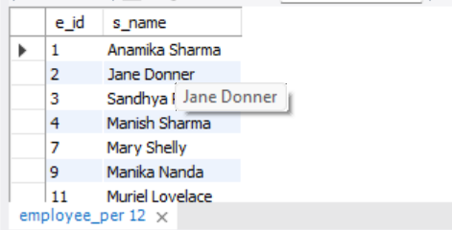
- Change the above so that the display is sorted on spouse names.
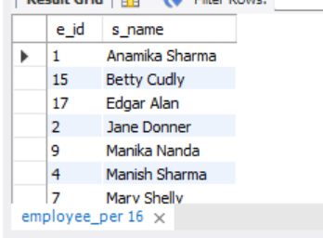
- How many employees do we have under each sex (male and female)?
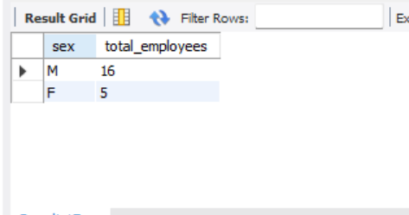
- How many of our employees are married and unmarried?
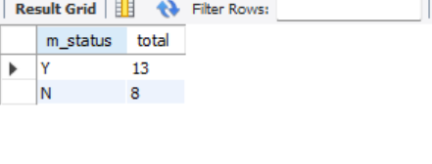
- Find the total number of children.
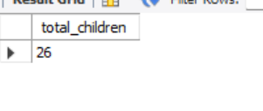
- Make unique groups of children and find the number in each group. Sort the display with the group having maximum children at the top.
